Welcome to the fifth segment of Getting Started with Google Suite. By the end of this segment, you should be able to explain how to access Google Sheets, be able to demonstrate the basics of how to use Google Sheets, and be able to explain the two main ways to work with Google Sheets offline.

**How to access Google Sheets?**

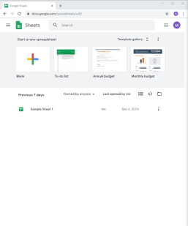There are two ways to access Google Sheets depending on what you are looking for. The first is to go to Google Sheets. To do this: Open Chrome, click in the address bar up at the top and type in “Google Sheets” and hit enter. In the search results that come up click on the second link that says “Google Sheets: Sign-In”. Using this route will allow you to easily access the template gallery and see what the templates look like without taking an extra step. The downside is that it will auto-create the file in your main Google Drive, which can cause file chaos if you do not take the time to organize it.

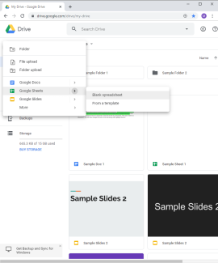The second way to access Google Sheets is to go through Google Drive. To do this: Open Chrome, click in the address bar at the top and type in “Google Drive” and hit enter. Click on the “Google Drive” that pops up in the search results and it will take you to your Drive. Then click on the “New” button in the top left corner, go down to Google Sheets, hover your mouse over the arrow and choose either the “Blank Document” or “From a Template”. Using this route will allow you to create the sheet in the folder where you want it to be, in turn keeping things organized. It also allows you to access the template gallery but does take an extra step with being able to view and choose the one you want to use.

**How to get started with Google Sheets**

For those that have used Microsoft Excel using Google Sheets will be very similar with just a few formatting options located in different places. Becoming proficient in Google Sheets will be just like becoming proficient in Microsoft Excel right after they release a new edition where they moved all the buttons. For those that are not familiar with Microsoft Excel then, good news, Google Sheets is easy to learn the basics.

By the end of this section you should know how to rename a file, be able to wrap text and resize columns, be able to add columns and rows, know where to go to effect the text, know how to sort charts, and know how to use basic functions and graphs.

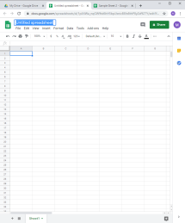 First things first open up a blank Google Sheets and click up on the “Untitled Spreadsheet” and type in a file name that will match what you are using the Google Sheet for. Google Sheets shares the same main function as Microsoft Excel. It is data processing software which means it is generally used for complex lists and for number crunching. With this in mind I have generated some budget numbers to demonstrate with.

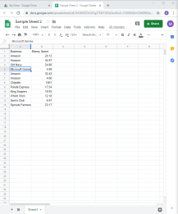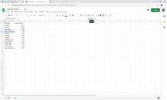Looking at my lists of businesses you will noticed that row 5 has text that is being clipped. There are two ways that you could go about fix this. The first is to click on the cell, then up in the top menu on the right side click on the text wrapping icon and change it from “Overflow” to “Wrap.” The second option is to position the mouse up between column A and B until the mouse becomes a double-sided arrow pointing in two directions and then click which will expand the cell out to fit all the content in the column. I generally prefer the change the entire column then to change it cell by cell.

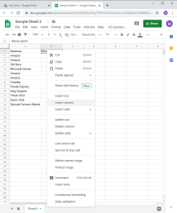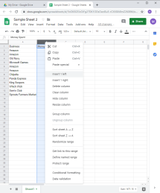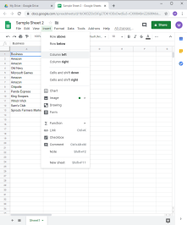 Next I would like to add a column in between Business and Money spent so that I could add categories. To do this you have three options. After clicking on B1 the “Money Spent” cell you could click on “Insert” then click on “Column Left” which would insert a column in between Business and Money Spent. Or you could just right click once you have clicked on “Money Spent” and click “Insert Column” which will insert a column to the left. If you would like more control when right clicking on where the column goes then you need to select the entire column before right clicking. To do so just click up on the B at the top then right click. Doing this gives you the option to “Insert 1 Left” or “Insert 1 Right.” You can also add rows in the same way, just make sure that you are right clicking on the row number. Doing so gives you the option to “Insert 1 above” or “Insert 1 below”

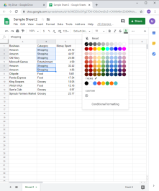 Now that I have added my categories I would like to change the text color for each different category. To do this click on the first cell, press and hold the control button, and then click on the cells that match the category. Then click on the A with a thick black line under it which will open a drop down menu allowing you to pick a color. The other text modification options are also up on the top bar that would allow you to change the font, the text size, and also the alignment of the text in the sheet.

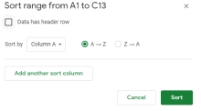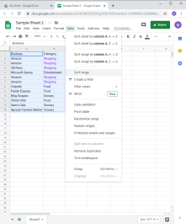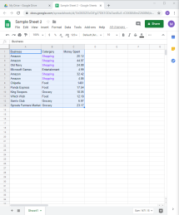 Instead of changing the color of the categories to make it easier to see where the money was spent you may want to sort the chart to group the categories. Click on the Business cell, press and hold the shift key and then click on the 23.17 cell in the bottom right-hand corner. This will select the entire chart. Then click on “Data” and then “Sort Range” this will open a pop-up box allowing you to customize how Sheets will sort the information. Clicking “data has header row” will remove the top row from the sort. Clicking “Business” will cause a drop down menu to appear allowing you to choose which column you would like it to sort by. If you would like it to sort by two columns, maybe you want the Money spent to be from lowest to greatest, you could click on “Add Another Sort Column” and tell it which to sort by. If you do this it will work from the top of the box to the bottom of the box for sort priority, meaning it would first sort Category then Money Spent. Once you have set up how Sheets with sort the range go ahead and click “Sort.”

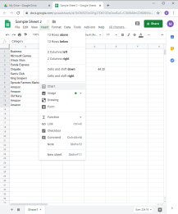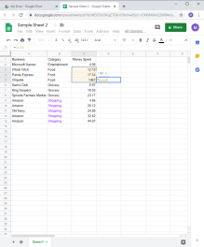 Lastly if you wanted to see how much money was spent in one category vs another you have two ways to do so. You can either create a sum function which would give you a numeric total or you could insert a pie chart to give you a visual. Let’s start with a sum function. Click on D5 and type a “=sum(” then click on C3 and holding the left mouse button down drag down to C5. Click back over in D5 type in a ) and then hit enter. The function you just typed automatically totals the three cells you selected. There are more functions to explore but the sum tends to be the most used. If you created a sum function for the grocery and shopping category it would be easy to see how much was spent across the four categories in total.

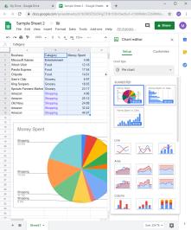 Another option, which is more visual, is to turn the chart into a pie graph. To do this click in the Category cell, hold the shift key an then click in the 44.97 cell in the bottom right-hand corner. Click on Insert up in the top menu, click on Chart. Google Sheets will attempt to determine which chart is best to displaying the data selected; in this case it got it right and displayed a pie chart. If it decided to display the data as a bar graph you can change the chart type by clicking the down arrow under chart type and selecting the type of graph that you want. With the current display each category 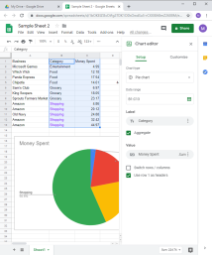is showing up multiple times, to simplify the graph so it just shows the four categories click on the box next to “Aggregate” and it will take it down to the four categories and will show the percent of the graph that categories takes up.

While there is still more that could be covered with how to use Google Sheets this is it for the basics.

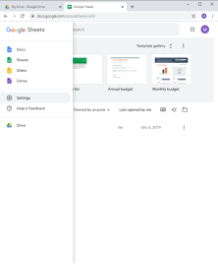**How to Work with Google Sheets Off-line**

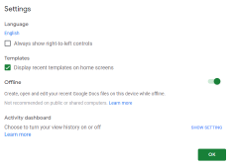If you ever need to work off-line yet the file you need to work with is a Google Sheets don’t worry you have a couple of options. One option, if you are staying on the same computer, is to turn on off-line mode. To do this: Open Chrome, click in the address bar at the top and type in “Google Sheets” and hit enter. In the search results that come up click on the second link “Google Sheets: Sign-in”. Then in the top left-hand corner click on the triple-stacked lines, click “Settings” and make sure that the slider next to Offline is Green. WARNING this only works with your recent Google Sheets files so you need to make sure that you have opened what you want to work with within a day or two of when you are planning on going offline.

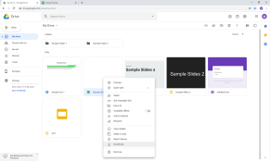The second option would be to download any Google Sheets that you want to work with as an Excel Document, edit as needed and then when you have internet back upload them and convert them back to Google Sheets. There are two ways to do this. If you are just planning on working with a single file then go to your Google Drive, locate the file, right-click on the file and select download. Once the file downloads, it will show up in the bottom left-hand corner of your screen. Go ahead and open the file and save it to a location you will be able to find it again. Suggestions would be either the “Desktop” or “My Document.”

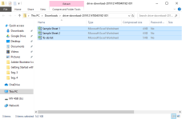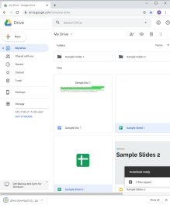If you are planning on downloading multiples files then the easiest way would be to select all of the files either by selecting the first file pressing and holding the shift key and then selecting the last file if they are in order or by selecting the first file, pressing the control key and then selecting the next file if they are not in order. Once the files are selected release the shift or control key, right-click, and click on “download.” A little box will pop up in the bottom right-hand corner to show you the progress, and then once the files have been downloaded a folder will pop up in the bottom left-hand corner. You are going to want to click on it then select all of the files you have downloaded and drag them to a location where you will be able to find them again. Suggestions would be either the “Desktop” or “My Document.”

This concludes this segment of Getting Started with Google Suite. By now you should be able to explain how to access Google Sheets, be able to demonstrate the basics of how to use Google Sheets, and be able to explain the two main ways to work with Google Sheets offline.

The next segment will be about Google Forms.